**Running the test in K6 Cloud**

1. Sign in with K6 cloud (<https://app.k6.io/account/login>).
2. Login into K6 cloud using your credential and note down the project number

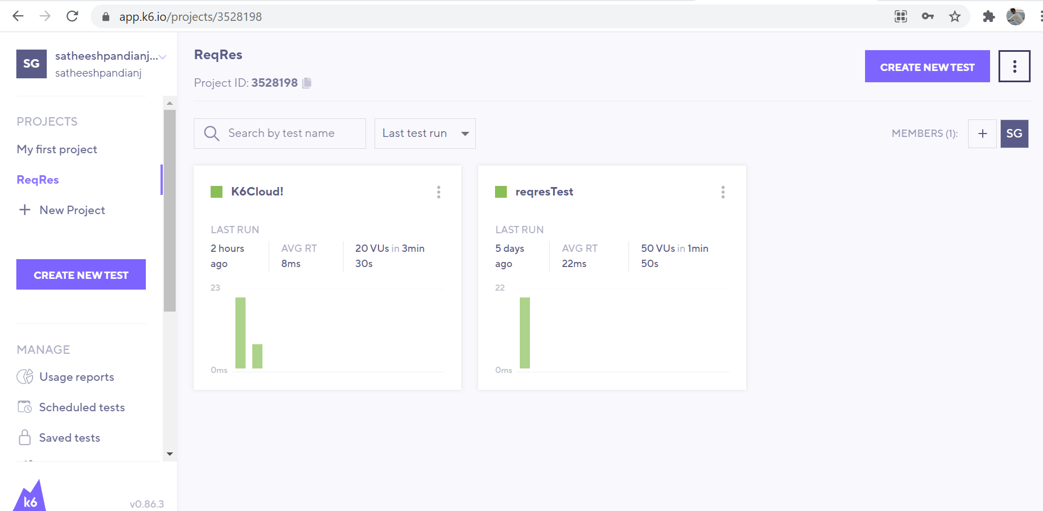

1. Update the project number in the script

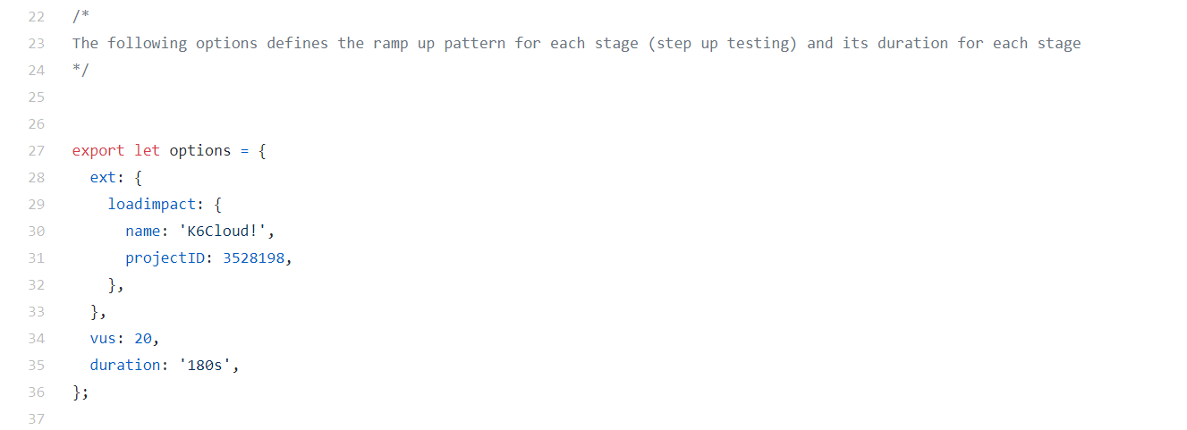

1. Login into K6 cloud via terminal (user k6 login cloud <your token>). Your token can be found in your profile @ app.k6.io

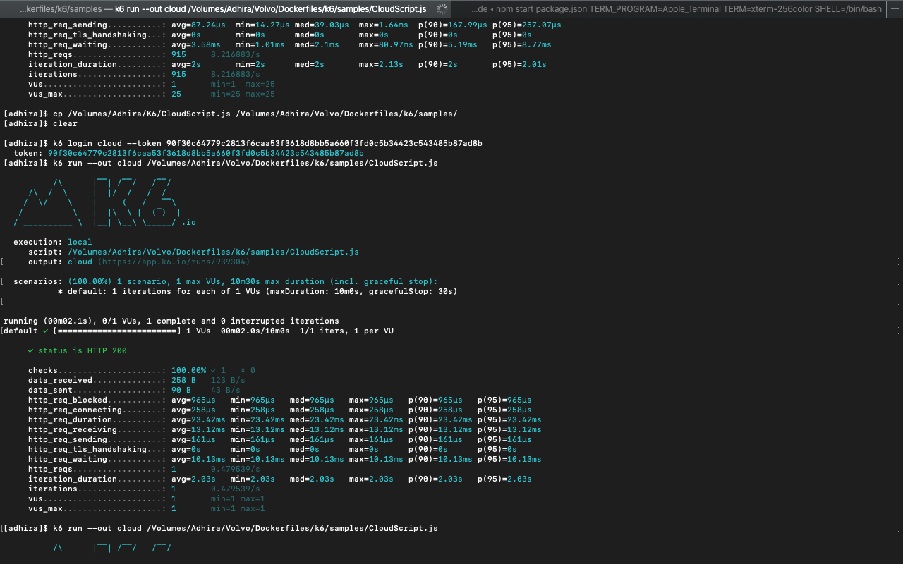

1. Run the test (use k6 run --out cloud /<Script Path>/script.js)



1. View the test result in the browser (you can find the link in the output field in the above snapshot)

